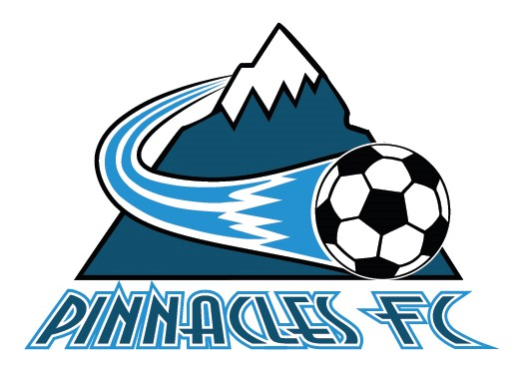
2024-2025 Pinnacles FC
BOARD OF DIRECTORS
NOMINATION FORM
This form must be submitted to signuppinnacles@yahoo.com by 4:00pm on August 31, 2024. Late forms will not be accepted!

Positions Open for Election at the AGM for a *one year term (please check one):

- Chair
- Vice Chair
- Treasurer
- Discipline Chair
- Director At Large
*This term will also include the rest of September following the SGM and the month of October due to special circumstances.

Nominated Person (print):______________________________________________________
Nominated Person (signature):___________________________________________________
Nominated By (Voting Member print):______________________________________________
Nominated By (Voting Member signature):__________________________________________
Nominated By (Voting Member print):______________________________________________
Nominated By (Voting Member signature):__________________________________________

What related skill and/or experience would you bring to the Directorship?
____________________________________________________________________________________________________________________________________________________________________________________________________________________________________
What do you hope to contribute to the Association as a Director?
____________________________________________________________________________________________________________________________________________________________________________________________________________________________________

How do you see yourself contributing to the ongoing growth and development of the Board?
____________________________________________________________________________________________________________________________________________________________________________________________________________________________________

What is your vision for Pinnacles FC? How would you contribute to fulfilling that vision?
____________________________________________________________________________________________________________________________________________________________________________________________________________________________________

Pinnacles FC Special General Meeting
September 19, 2024 @ 7pm
Cleland Community Theatre
325 Power Street, Penticton BC, V2A 7K9

For more information please contact signuppinnacles@yahoo.com

